**ASSEESSMENT OF MARGINAL WORKERS IN TAMIL NADU**

|  |  |
| --- | --- |
| **Date** | **10-10-2023** |
| **Team ID** | **4498** |
| **Project Name** | **ASSEESSMENT OF MARGINAL WORKERS IN TAMIL NADU** |

**Table of Contents**

|  |  |
| --- | --- |
| 1 | Introduction |
| 2 | Problem Statement |
| 3 | Design and Innovation Strategies |
| 3.1 | Data Collection and Feature Engineering |
| 3.2 | Data Pre-processing |
| 3.3 | Model Selection and Training |
| 3.4 | Geographic Analysis |
| 3.5 | Market Sentiment Analysis |
| 3.6 | Explainable AI (XAI) |
| 3.7 | Continuous Learning |
| 4 | Conclusion |

**1. Introduction**

The assessment of marginal workers plays a crucial role in workforce management and development. Marginal workers are individuals who may not be performing at their full potential within the workplace. This assessment process is designed to evaluate their current performance, identify factors contributing to their marginal status, and implement strategies to help them improve and contribute more effectively to the organization

**2. Problem Statement**

Predicting house prices accurately is a complex task influenced by a multitude of factors, including property features, location, market trends, and economic conditions. The central problem of this project is to build a model that delivers precise house price predictions by incorporating these intricate factors.

**3. Design and Innovation Strategies**

**3.1. Data Collection and Feature Engineering**

Data collection and feature engineering are essential steps in any machine learning project, especially when it comes to a sensitive topic like marginal workers in Tamil Nadu. Marginal workers are often underrepresented in data sets, and their unique experiences and challenges can be difficult to capture.

The quality of your data and the effectiveness of your feature engineering can significantly impact the accuracy and reliability of your assessment of marginal workers. Collaboration with experts in HR and data analysis is essential to make informed decisions during this process.

**3.2. Data Pre-processing**

Marginal workers are often underrepresented in data sets, and their data may be incomplete or inaccurate. In addition, marginal workers may be reluctant to share their data, due to concerns about privacy or fear of discrimination.

As a result, it is important to carefully pre-process data on marginal workers in TN before using it for machine learning. Data preprocessing is often an iterative process, and the specific steps may vary depending on the characteristics of your data and the goals of your assessment. It's essential to tailor your preprocessing steps to the unique challenges and requirements of assessing marginal workers in Tennessee.

**3.3. Model Selection and Training**

Model selection and training are two important steps in any machine learning project. Model selection involves choosing the right machine learning algorithm for the problem you are trying to solve. Training involves feeding the algorithm the pre-processed data so that it can learn to make predictions. To Choose appropriate machine learning or statistical models for the task. Common choices include linear regression, decision trees, random forests, or more advanced techniques like neural networks. The choice of model should depend on the nature of the data and the specific goals of the assessment. Train the selected model on the training data, optimizing its parameters to achieve the best performance. This may involve techniques like cross-validation to prevent overfitting.

**3.4. Geographic Analysis**

Selecting an appropriate model and training it effectively is crucial for the assessment of marginal workers based on demographic characteristics like age, industrial category, and sex. Clearly articulate the problem you aim to solve with the model. In this case, it's likely a classification or regression task where you want to predict or analyze aspects related to marginal workers based on demographic features. Experiment with different hyperparameters of your selected model(s) to find the best combination for your data. You can use techniques like grid search or random search for hyperparameter optimization.

Use the validation dataset to assess the model's performance. Common evaluation metrics include accuracy, precision, recall, F1-score (for classification), and Mean Absolute Error, Mean Squared Error, or R-squared (for regression)

**3.5. Market Sentiment Analysis**

Analysing market sentiment for marginal workers involves monitoring news, social media, and economic indicators to gauge the perception of employment prospects and economic conditions for this group. Sentiment analysis tools can help track sentiment in real-time and provide insights into how economic changes impact marginal workers' sentiment and employment opportunities. It's important to consider factors like unemployment rates, job availability, government policies, and social sentiment to understand the overall sentiment in this market. Keep in mind that sentiment analysis is a dynamic field, and the tools and techniques for analysis may have evolved since my last update in September 2021.

**3.6. Explainable AI (XAI)**

Marginal workers, in the context of Explainable AI (XAI), refer to individuals or groups of people who may have limited technical expertise but are affected by AI systems. XAI aims to make AI systems more transparent and understandable to a broader audience, including these marginal workers. By providing clear explanations of how AI decisions are made, XAI can empower such individuals to better interact with and trust AI technologies, even if they lack deep technical knowledge. This inclusivity is crucial for ensuring that AI benefits all segments of society and minimizes potential biases and discrimination in AI-driven decisions.

**3.7. Continuous Learning**

Continuous learning and development play a vital role in improving the performance and job satisfaction of marginal workers in Tennessee (TN) or any workplace. Continuous learning is essential for marginal workers to improve their skills and increase their employability. These workers often face barriers to stable employment, and ongoing education and skill development can help them adapt to changing job markets and access better opportunities. Employers, government programs, and educational institutions can play a crucial role in supporting the continuous learning of marginal workers through training initiatives, flexible scheduling, and financial assistance. This approach can empower them to overcome challenges and enhance their career prospects.

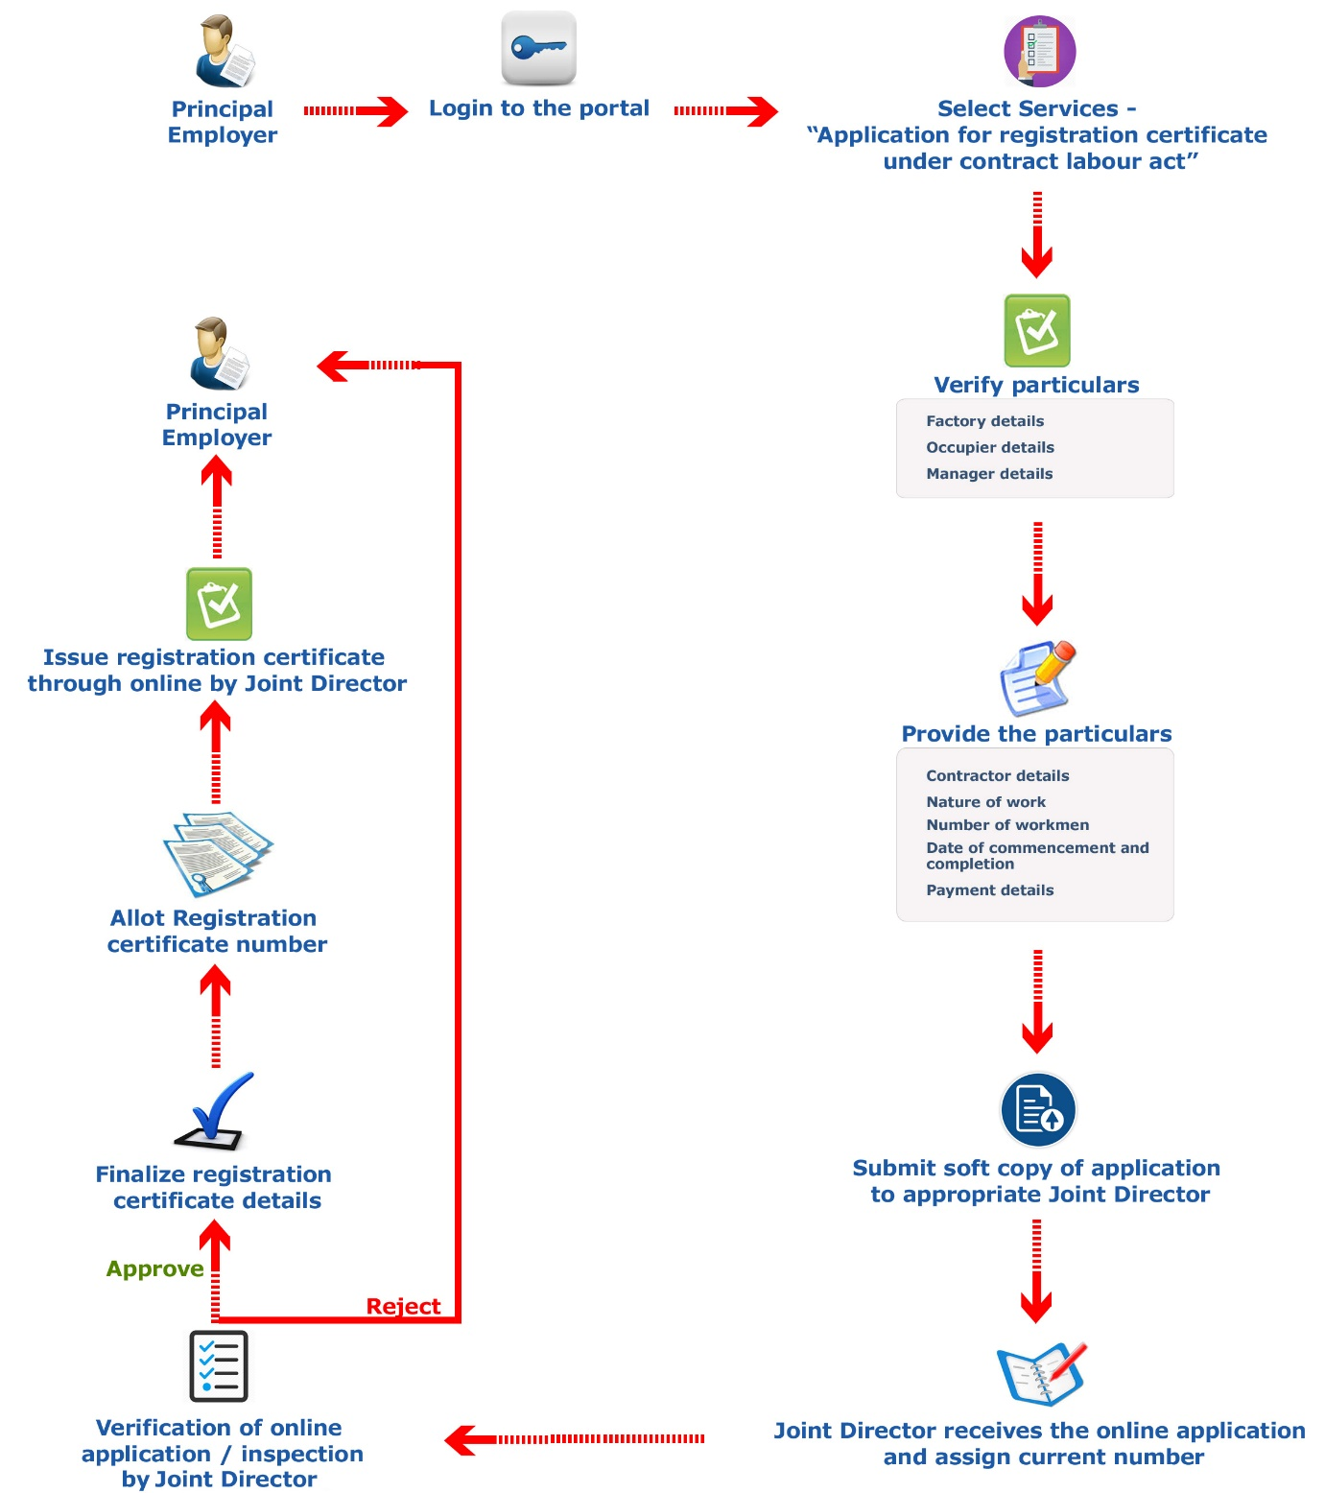

**4. Conclusion**

In conclusion, our project set out to analyze the demographic characteristics of marginal workers in Tamil Nadu, focusing on their age, industrial category, and sex. Through a comprehensive analysis and data visualization, we have gained valuable insights into the socioeconomic dynamics of this vulnerable population. Conducting longitudinal studies to track changes in the demographic characteristics of marginal workers over time. Complementing quantitative data with qualitative research to gain deeper insights into the experiences and aspirations of marginal workers. Assessing the effectiveness of existing policies and interventions in improving the socioeconomic status of marginal workers.

In conclusion, our analysis has shed light on the demographic composition of marginal workers in Tamil Nadu, offering valuable insights for informed decision-making and targeted support. By addressing the challenges faced by this vulnerable population, we can work toward a more inclusive and equitable society.